AI vs independent research verification table
Topic or claim | AI-generated roadmap | Independently verified information | Match / mismatch | Correction required | Final decision
Weeks 1–2: Spreadsheets | Learn spreadsheet basics and PivotTables. | Microsoft's official guide explains how PivotTables summarize and analyze worksheet data. Microsoft PivotTable guide. | Match | Include sorting, filtering, formulas, and basic charts before PivotTables. | Keep
Weeks 3–4: SQL | Learn SQL fundamentals, grouping, and joins using SQLBolt. | SQLBolt provides interactive browser-based SQL lessons and exercises. SQLBolt lessons. | Match | Add practice with SELECT, WHERE, GROUP BY, and JOIN. Explain tables and columns first. | Keep
Week 5: Python | Learn Python through Kaggle Learn. | Kaggle offers a Python course covering syntax, variables, functions, conditions, lists, loops, and other fundamentals. Its course page states that Kaggle Learn courses are free. Kaggle Python course. | Match | Start with programming fundamentals before moving to Pandas. | Keep
Week 6: Pandas | Learn data manipulation using Pandas tutorials. | The official Pandas getting-started documentation covers tabular data, reading files, DataFrames, and data processing. Pandas getting started. | Match | Allow time to install or access Python and practise with CSV files. | Keep
Week 7: Data cleaning | Handle missing values, duplicates, and inconsistent data. | The official Pandas resources support learning tabular-data operations and processing. Pandas tutorials. | Partial match | Add explicit exercises for missing values, duplicates, data types, and validation. | Keep and expand
Week 8: Statistics | Learn basic statistics using Khan Academy. | Khan Academy's Statistics and Probability course includes data analysis, distributions, study design, probability, and statistical inference. Statistics and Probability. | Match | Focus first on mean, median, spread, distributions, and correlation; leave advanced inference for later. | Keep
Week 9: Visualization | Learn Matplotlib and Seaborn. | Matplotlib provides official tutorials for creating and customizing plots. Matplotlib tutorials. | Partial match | Use the official Seaborn tutorial alongside Matplotlib. Practise bar charts, histograms, scatterplots, and clear labels. | Keep and expand
Week 10: Dashboard | Build a dashboard using Power BI. | Microsoft Learn offers a beginner Power BI module with no prerequisites, plus a learning path for preparing and visualizing data. Microsoft Learn Power BI training. | Match | Choose a beginner module and check the software and account requirements before starting. | Keep
Weeks 11–12: Portfolio project | Analyze retail sales and prepare a final portfolio project. | The listed learning resources teach relevant individual skills, but they do not independently prove that the proposed retail-sales project will be completed in two weeks. | Partial match | Choose a dataset early, reuse it throughout the roadmap, and reserve time for cleaning, analysis, visuals, conclusions, and documentation. | Keep with realistic scope
Total duration | 12 weeks at 5–7 hours per week. | The schedule provides 60–84 hours in total. This is a calculation, not a guarantee of learning outcomes. | Plausible, unverified | Track actual study time and simplify or extend tasks when necessary. | Keep as a target
Cost and accessibility | Prefer free learning resources. | Kaggle Learn describes its courses as free. The listed official documentation and learning pages are accessible online, but access to software, accounts, certificates, and every feature may vary. | Partial match | Label each resource separately as free learning material, paid software, optional paid certificate, or access requirement only after checking its current terms. | Verify before submission

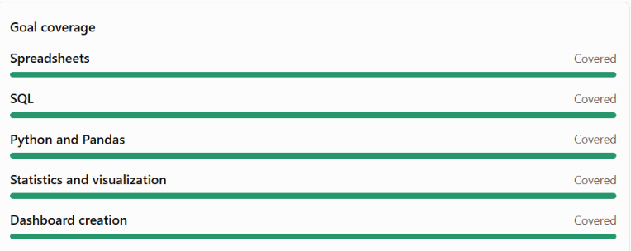

- the entire roadmap is fully validated, that every resource is free in every respect, or that completing it guarantees employment.
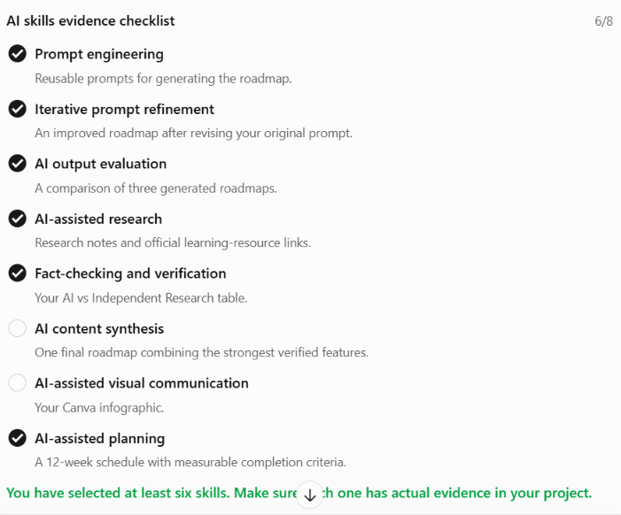

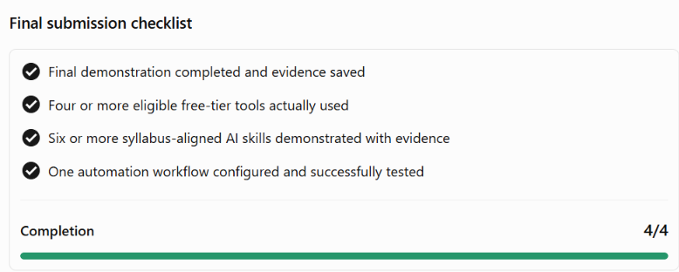

Conclusion: The AI-generated roadmap is a reasonable starting plan. Independent research supports the relevance of its main learning resources, while the project milestones and actual learning outcomes still need to be tested. Record those limitations in your verification table to demonstrate responsible use of AI.

